A Project Report on
Road Accidents Acknowledgement
Submitted in partial fulfillment of the requirements for the award of the degree of
Bachelor of Technology
In
Computer Science and Engineering
Submitted by
Aditya Pandey (18P31A0501)
Gaurav Kumar (18P31A0521)
Vishwajit Singh (18P31A0558)

Under the esteemed supervision of
Mrs. J. Divya Lalitha Sri, M. Tech (Ph.D)
Assistant Professor


ADITYA COLLEGE OF ENGINEERING & TECHNOLOGY
(Approved by AICTE, New Delhi & Affiliated to JNTUK, Kakinada)
Surampalem, East Godavari District
Andhra Pradesh - 533 437
2018-2022

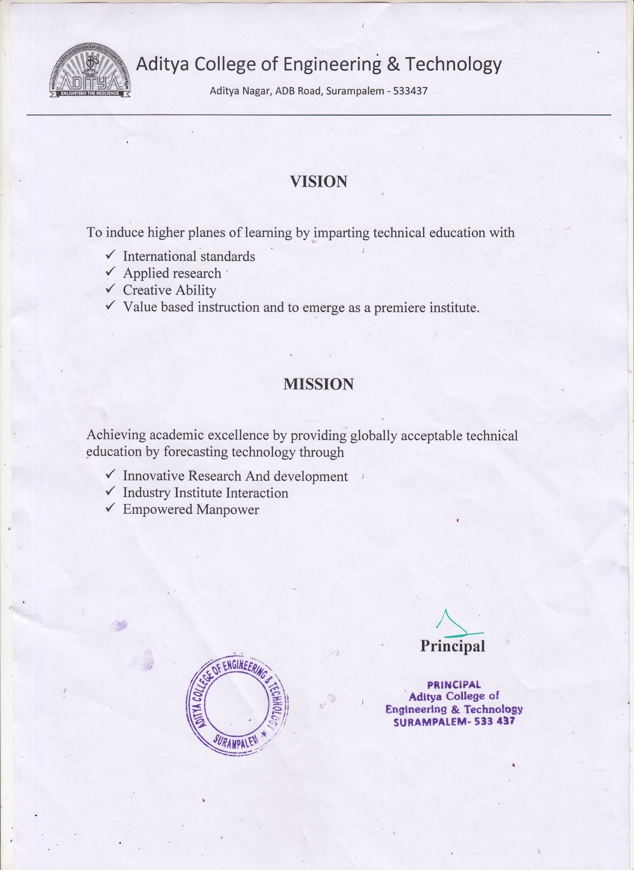

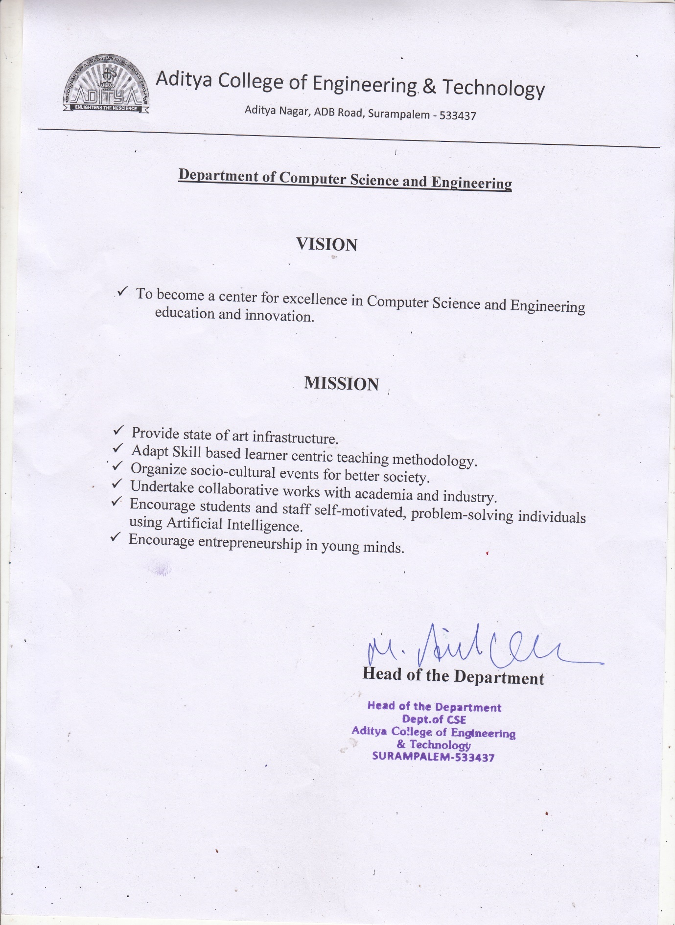

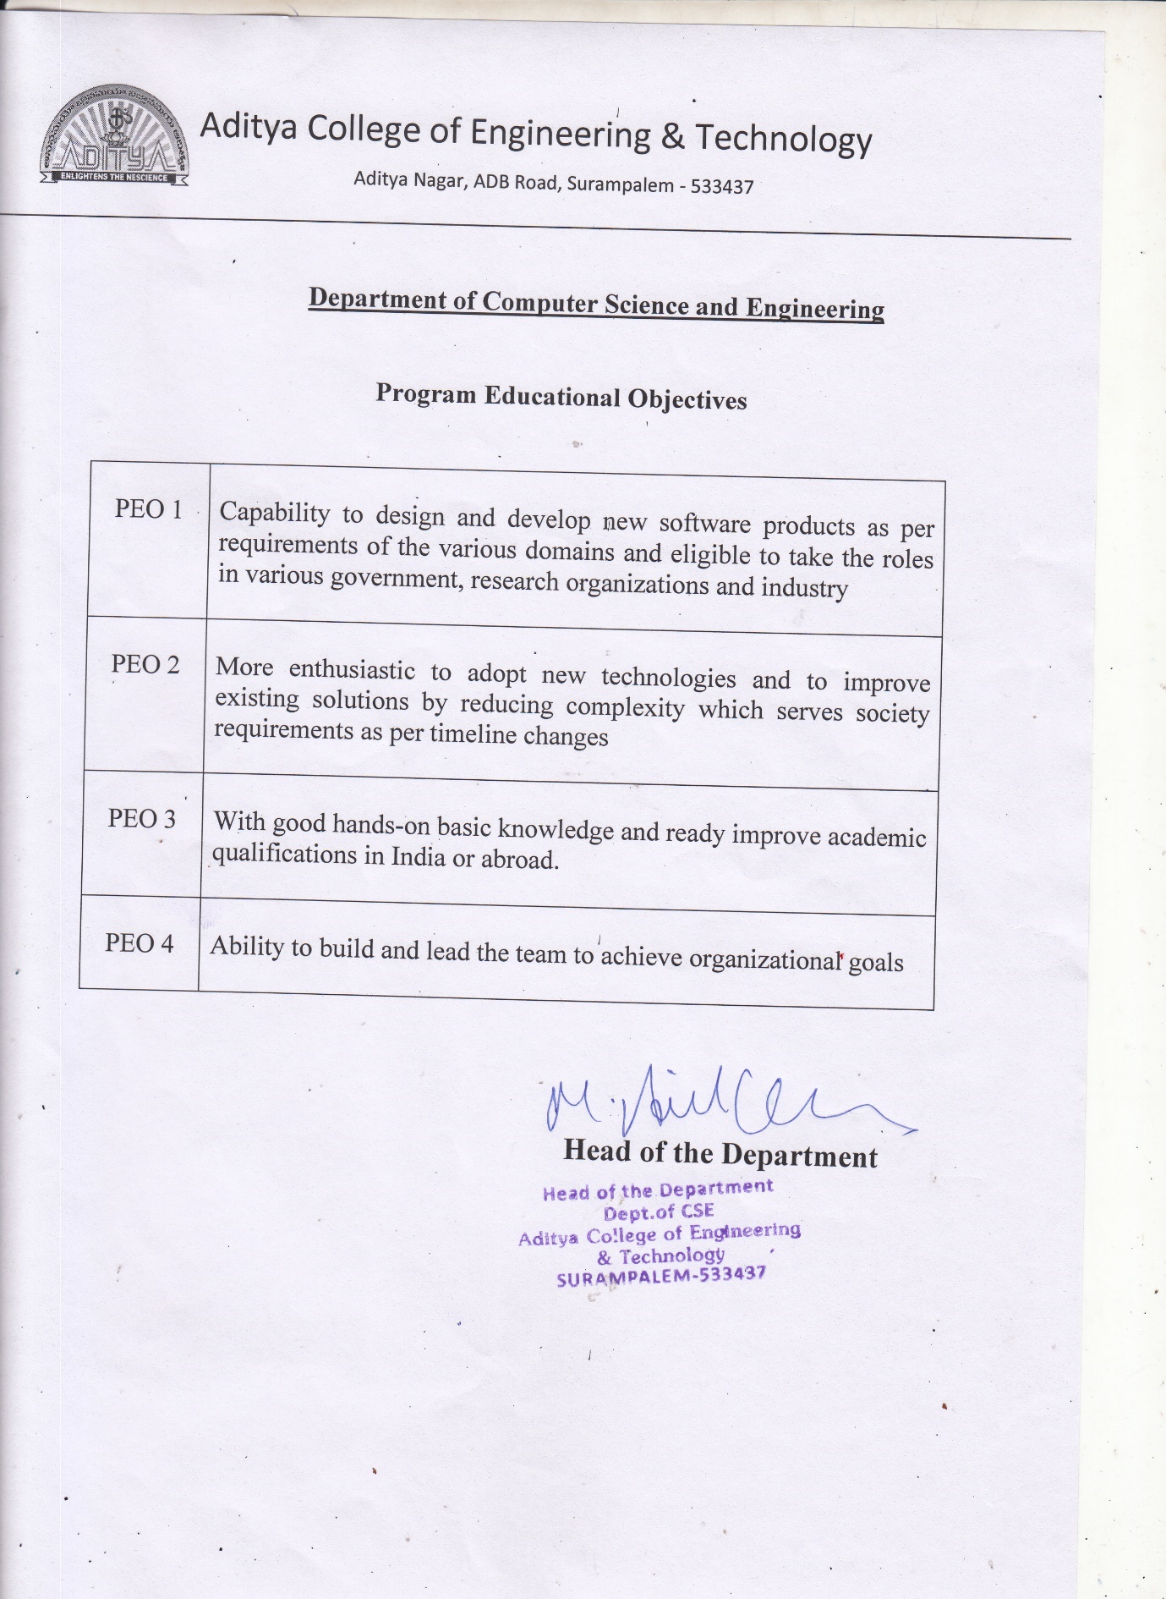

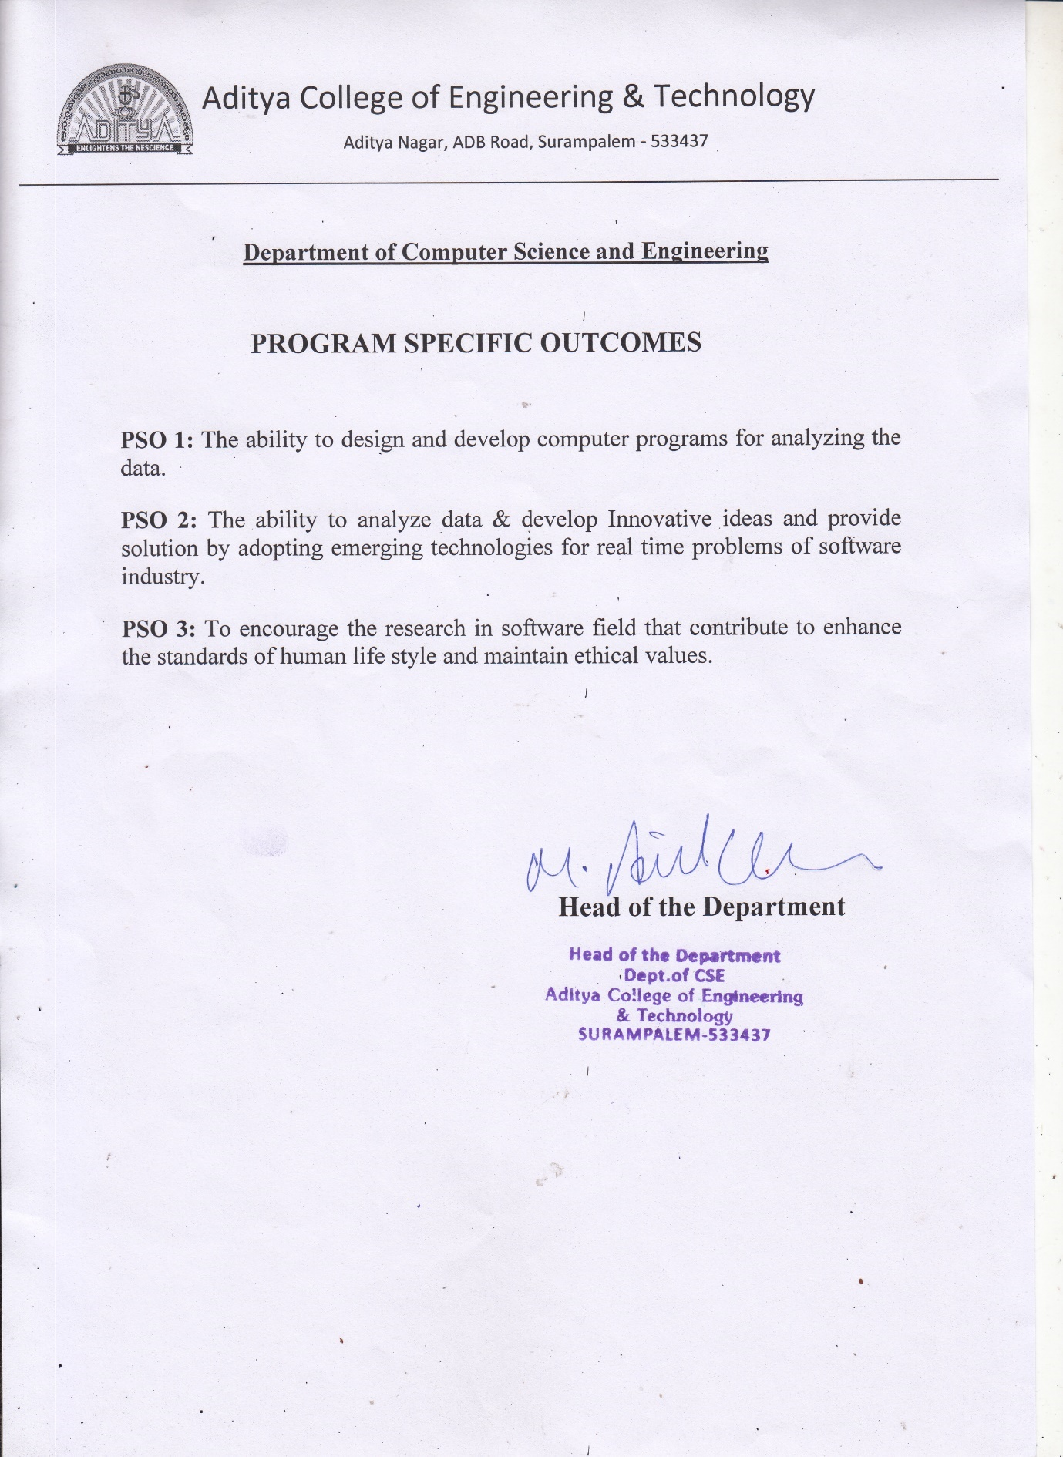

ADITYA COLLEGE OF ENGINEERING & TECHNOLOGY
(Approved by AICTE, New Delhi & Affiliated to JNTUK, Kakinada)

Department of Computer Science and Engineering

CERTIFICATE

This is to certify that the project work entitled, " ROAD ACCIDENTS ACKNOWLEDGEMENT ", is a bonafide work carried out by ADITYA PANDEY (18P31A0501), GAURAV KUMAR (18P31A0521), VISHWAJIT SINGH (18P31A0558), in partial fulfillment of the requirements for the award of the degree of Bachelor of Technology in COMPUTER SCIENCE AND ENGINEERING from Aditya College of Engineering and Technology, Surampalem, during the academic year 2021-2022.
This project work has not been submitted in full or part to any other University or educational institute for the award of any degree or diploma.

PROJECT SUPERVISOR  Mrs. J. Divya Lalitha Sri, M. Tech (Ph.D)  Assistant Professor |  | HEAD OF THE DEPARTMENT  Dr. M. Anil Kumar,  M. Tech  Professor

EXTERNAL EXAMINER

DECLARATION

We hereby declare that this project entitled " ROAD ACCIDENTS ACKNOWLEDGEMENT " has been undertaken by us and this work has been submitted to Department of Computer Science & Engineering, ADITYA COLLEGE OF ENGINEERING AND TECHONOLOGY, Surampalem affiliated to JNTUK, Kakinada, in partial fulfillment of the requirements for the award of the degree of Bachelor of Technology in COMPUTER SCIENCE AND ENGINEERING.
We further declare that this project work has not been submitted in full or part to any other University or educational institute for the award of any degree or diploma.

PROJECT ASSOCIATES

Aditya Pandey (18P31A0501)
Gaurav Kumar (18P31A0521)
Vishwajit Singh (18P31A0558)

ACKNOWLEDGEMENT

It is with immense pleasure that we would like to express our indebted gratitude to my project supervisor, Mrs. J. DIVYA LALITHA SRI, M. Tech (Ph.D) who has guided us a lot and encouraged us in every step of project work, her valuable moral support and guidance has been helpful in successful completion of this Project.
We wish to express our sincere thanks to Dr. M. ANIL KUMAR, M. Tech, Head of the Department of CSE, for his valuable guidance given to us throughout the period of the project work.
We feel elated to thank Principal, Dr. T. K. RAMA KRISHNA RAO, M. Tech, of Aditya College of Engineering and Technology for his cooperation in completion of our project and throughout our course.
We feel elated to thank Dr. A. RAMA KRISHNA, M. Tech, Dean (Academics & Administration) of Aditya College of Engineering and Technology for his cooperation in completion of our project work.
We wish to express our sincere thanks to all faculty members, and lab programmers for their valuable guidance given to us throughout the period of the project.
We avail this opportunity to express our deep sense and heart full thanks to the Management of Aditya College of Engineering & Technology for providing a great support for us by arranging the trainees, and facilities needed to complete our project and for giving us the opportunity for doing this work.
PROJECT ASSOCIATES
Aditya Pandey | (18P31A0501)
Gaurav Kumar | (18P31A0521)
Vishwajit Singh | (18P31A0558)

INDEX
CHAPTER PAGE No
LIST OF FIGURES xii
LIST OF TABLES xiii
ABSTRACT xiv
1. INTRODUCTION 1
1.1 Purpose of the System 2
1.2 Scope of the System 2
1.3 Current System 3
1.4 Proposed System 4
1.4.1 Why Our Approach Is Better 4
2. REQUIREMENT ANALYSIS 6
2.1 Functional Requirements 7
2.2 Non-Functional Requirements 7
2.2.1 User Interface and Human Factors 7
2.2.2 Software Requirements 7
2.2.3 Hardware Requirements 7
2.2.4 Usability 8
2.2.5 Reliability 8
2.2.6 Performance 8
2.2.7 Supportability 8
2.2.8 Security Requirements 9
2.2.9 Resource Requirements 9

3. MODULES 10
3.1 Introduction 11
3.1.1 User 11
3.1.2 Admin 11

4. SYSTEM ANALYSIS 12

4.1 Introduction 13
4.2 UML diagram 13
4.2.1 User model view 13
4.2.2 Admin model view 13
4.3 Use case diagrams 13
4.3.1 Actors 14
5. SYSTEM DESIGN 15
5.1 Introduction 16
5.2 Subsystems 16
5.2.1 Subsystem for admin 16
5.2.2 Subsystem for user 17
5.3 Class Diagram 17
5.4 Sequence Diagram 18
5.5 Collaboration Diagram 19
5.6 Activity Diagram 19
6. IMPLEMENTATION 21
6.1 Backend Implementation 22
6.1.1 Dataset 23
6.1.2 Libraries Used 24
6.2 Frontend Implementation 25
6.3 Random Forest Algorithm 26
6.4 Source Code 28
6.4.1 Random_Forest.ipynb 28
6.4.2 Api_Call_Pred.py 33
7. TESTING 36
7.1 Type of Test 37
7.1.1 Unit Testing 37
7.1.2 Integration Testing 37
7.1.3 Functional Test 37
7.1.4 System Test 38
7.1.5 White Box Testing 38
7.1.6 Black Box Testing 38
7.2 Test Strategy and Approach 39
7.2.1 Test Objectives 39
7.2.2 Feature to be Tested 39
7.2.3 Test Result 39
7.2.4 Acceptance Testing 39
8. OUTPUT SCREENS 40
8.1 User 41
8.2 Admin 42
CONCLUSION 45
BIBLIOGRAPHY 47

 | LIST OF FIGURES
S.No. | NAME OF FIGURE | PAGE No.
1 | 1.2.1 No. Of Accident in year | 3
2 | 4.3.1 Use case diagram of Road accident acknowledgement system | 14
3 | 5.2.1 Block diagram of proposed system for admin | 16
4 | 5.2.2 Block diagram of proposed system for user | 17
5 | 5.3.1 Class diagram Icon | 17
6 5.3.2 Class diagram for Road Accident Acknowledgment system 18

7 5.4 Sequence Diagram for Road accident acknowledgment system 18

8 5.5 Collaboration Diagram for Road Accident acknowledgment 19
system

9 5.6 Activity Diagram for Road Accident acknowledgment system 20

10 6.1.1 Features in the UK road accident data set 23

11 6.1.2 Feature used in Random Forest Classifier 24

12 6.2.1 Interaction (Prediction) Page 25

13 6.2.2 Fetching data from Google Map 26

14 6.3 Random Forest Algorithm 27

15 8.1.1 User Home Page 41

16 8.1.2 User Prediction Page 41

17 8.1.3 Prediction Page (Output) 42

18 8.2.1 Admin Login page 42

19 8.2.2 Admin dataset 42

20 8.2.3 To upload CSV file 43

21 8.2.4 Upload single dataset 43

22 8.2.5 View Dataset 43

23 8.2.6 Logout success page 44
LIST OF TABLES

S.No. | NAME OF TABLE | PAGE No.
1 | 1.2 Road Accident Death in London | 3
2 | 1.4.1 Accuracy of Different Machine Learning Algorithm | 5

ABSTRACT
In recent years, road accident has become a global problem and are marked as the ninth prominent cause of death in the world. Due to the enormous number of road accidents every year, it has become a major problem in India. It is entirely inadmissible and saddening to allow its citizen to kill by road accidents. Consequently, to handle this overwhelmed situation, precise analysis is required.
Here we proposed the real-time application which is useful for the government sector as well as travelers, to avoid and tackle accidents. Here, traffic safety represents an important part of our lives, so it is necessary to continuously improve within all possible and available opportunities and resources.
Our proposed system describes one possibility of how to use the collected data about traffic accidents to mine frequent patterns and important factors causing different types of accidents.
Here we provide two Sub-System, one for a user and another for traffic police (nearby police station). Users can have access to data, which is represented over a map. In the map, red color marker represents a high probability of accident whereas yellow and green color represents the mild and low probability of an accident.
The Same goes for another sub-system which is handled by the police, and they will maintain the database. Using the data, they can be more active at a particular time.

